1. Steps to execute

Need to download and replace chromedriver.exe from <https://chromedriver.chromium.org/downloads> based on your chrome version

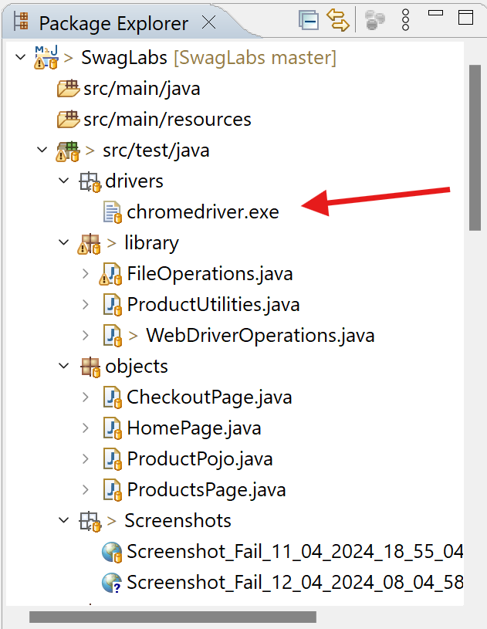



To run into headless mode need to make **Headless=true** in Configuration.properties

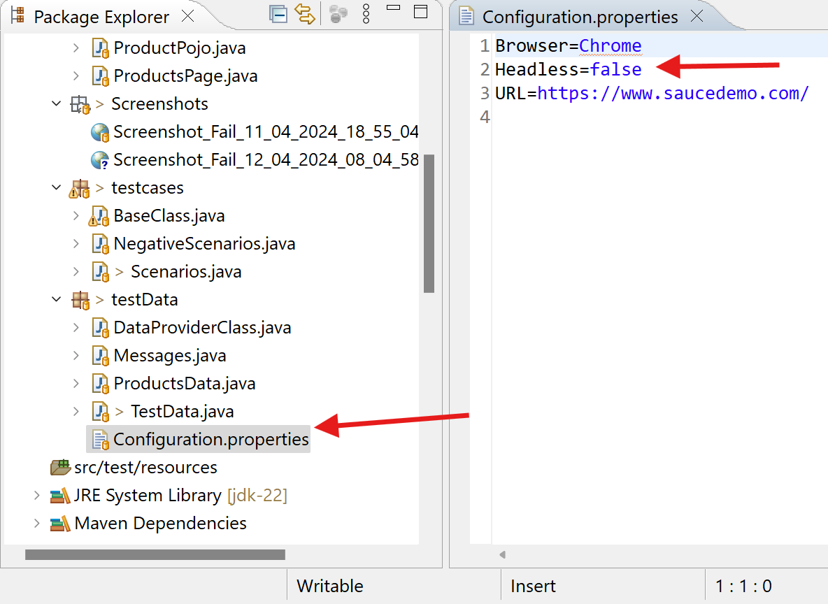

1. Need to right click on any of the testing xml and click Run As > TestNG Suite

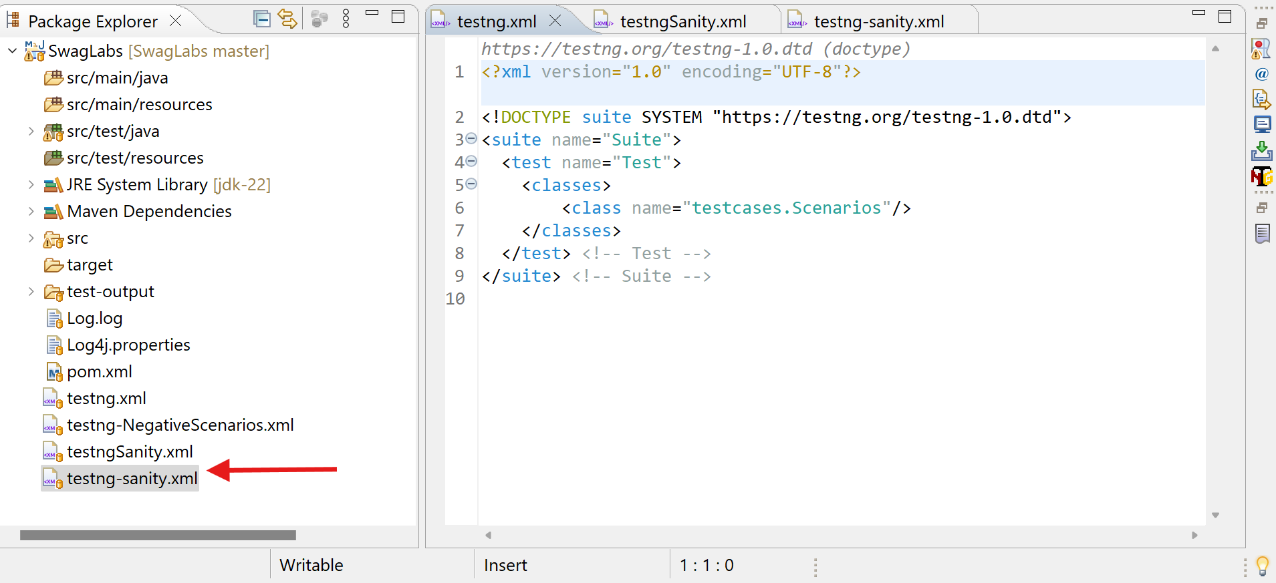

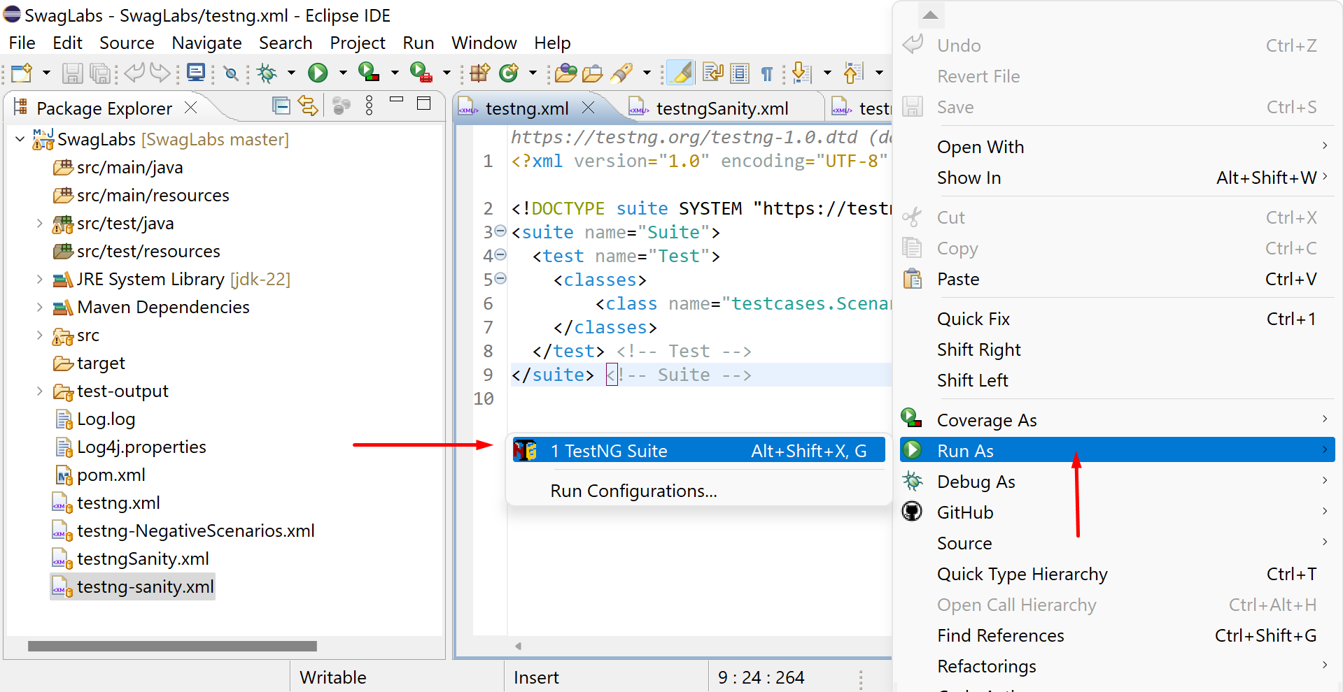

1. Once the execution is done – In test-output folder open **index.html** to see test ng report.

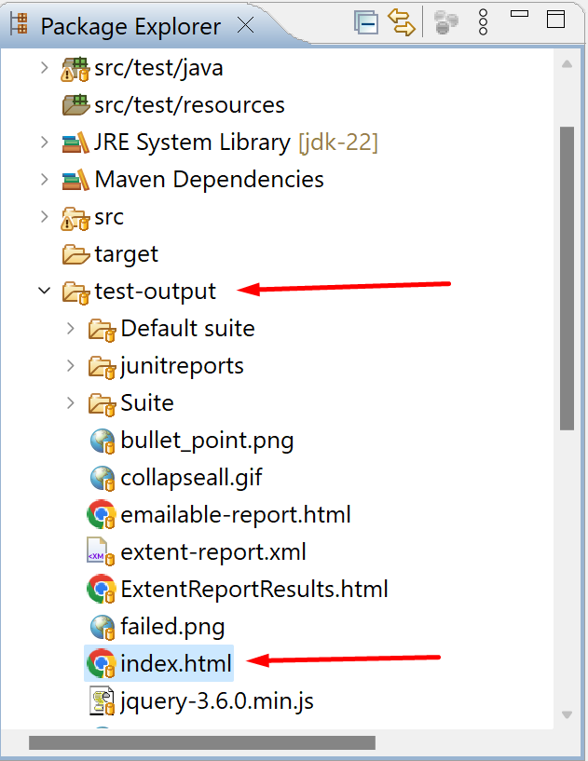

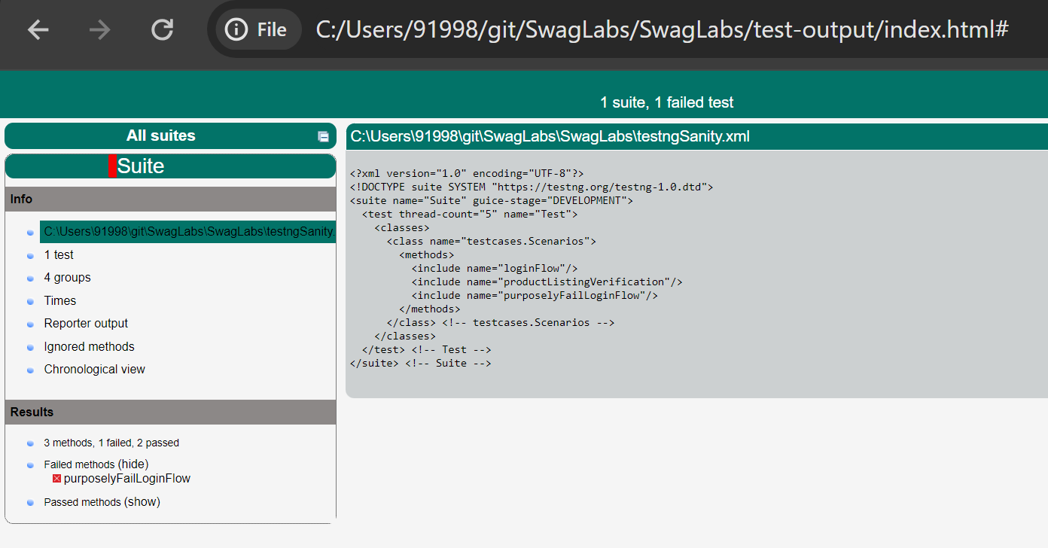

1. In test-output folder open **emailable-report.html** to see test ng emailable report.

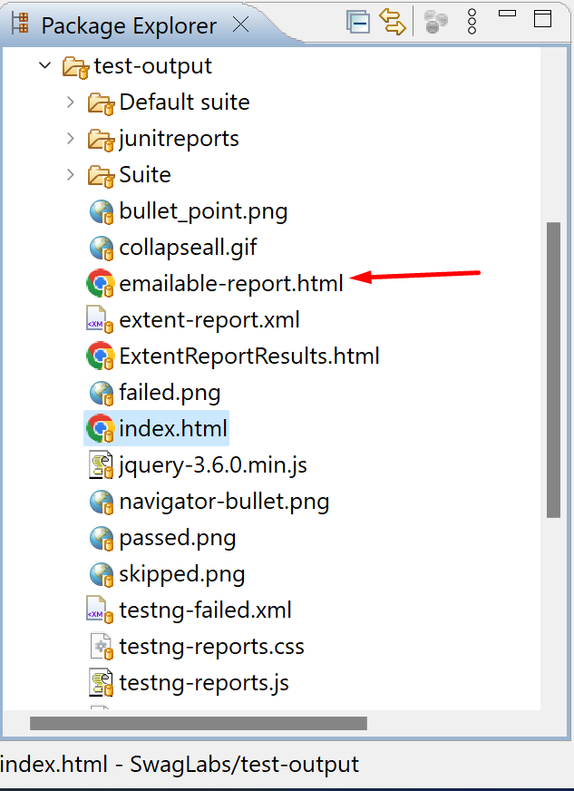

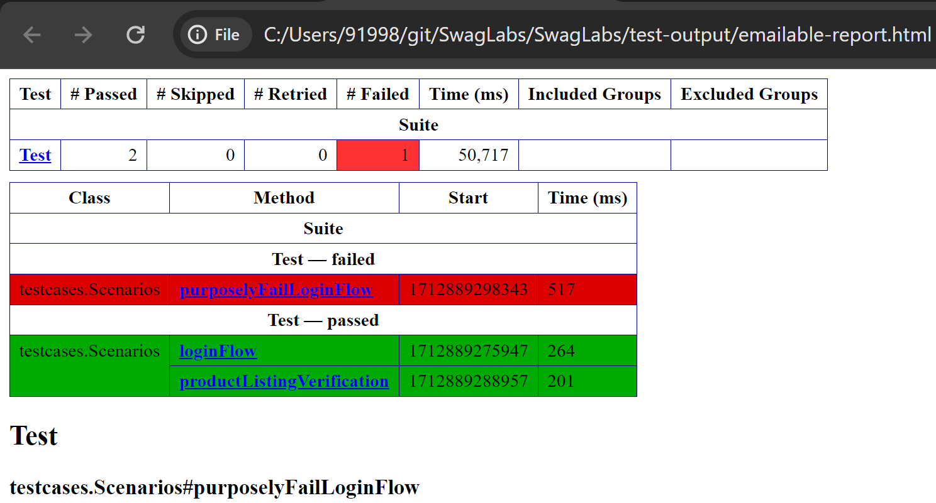

1. In test-output folder open **ExtentReportResults.html** to see extent report.

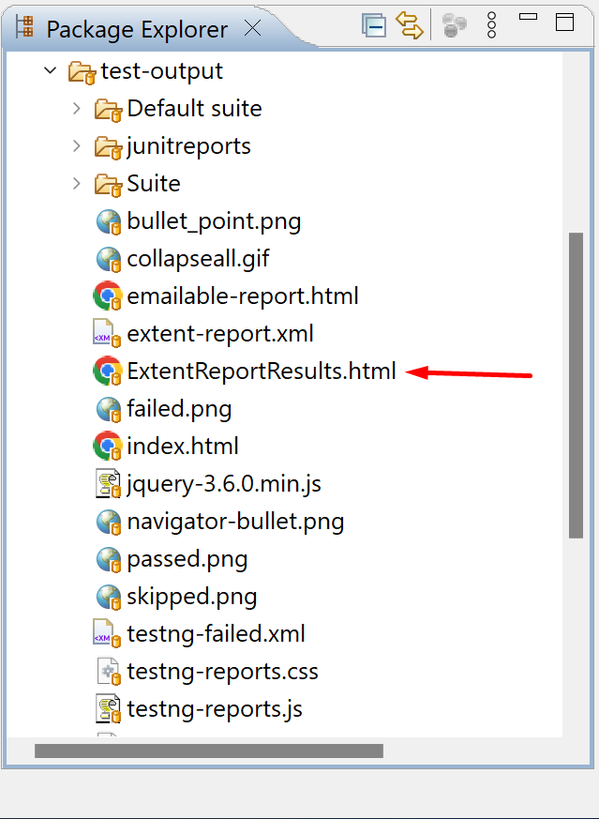

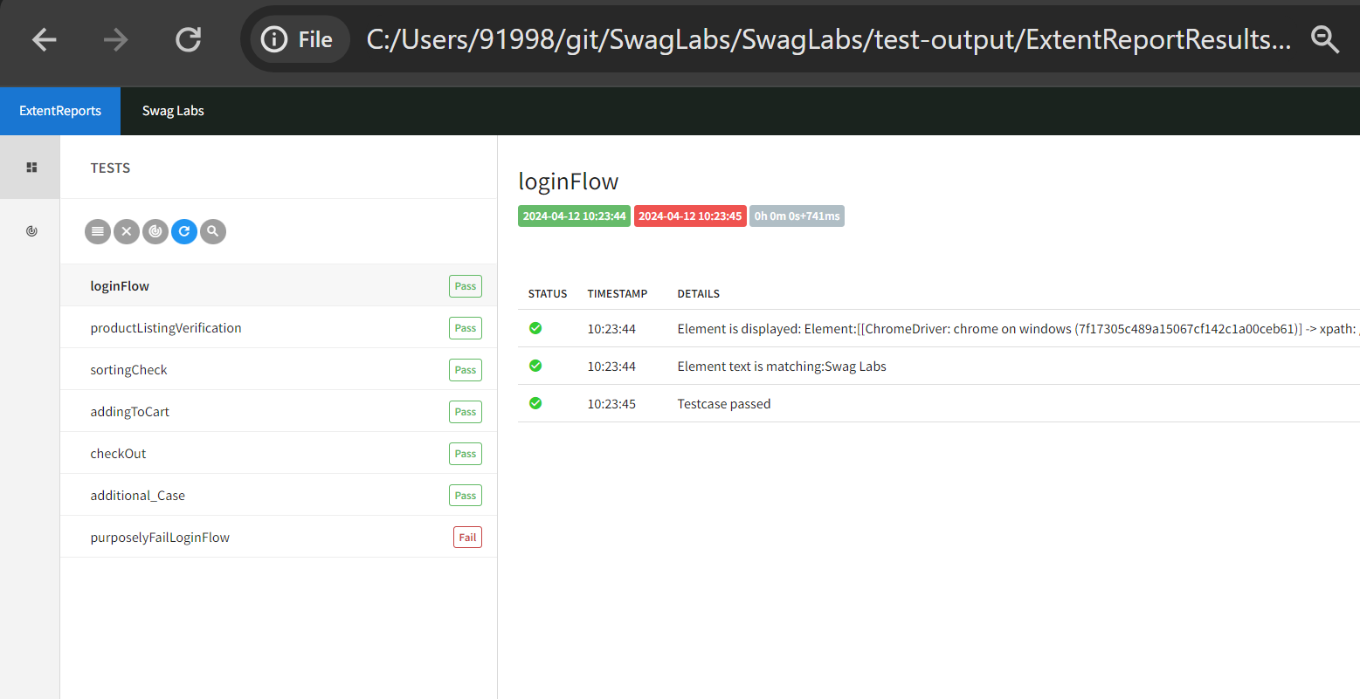

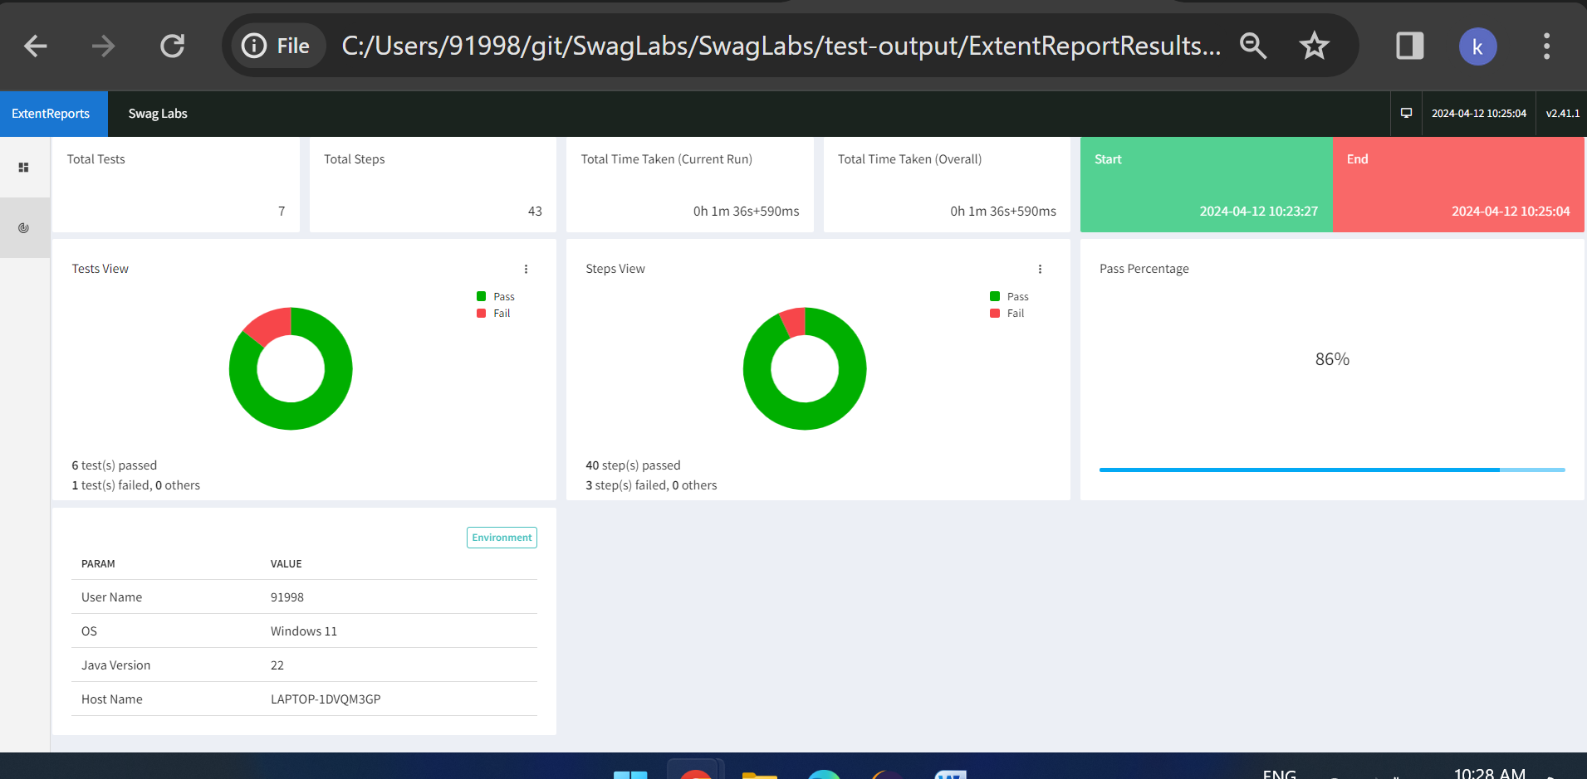

1. Log.log contains step by step results

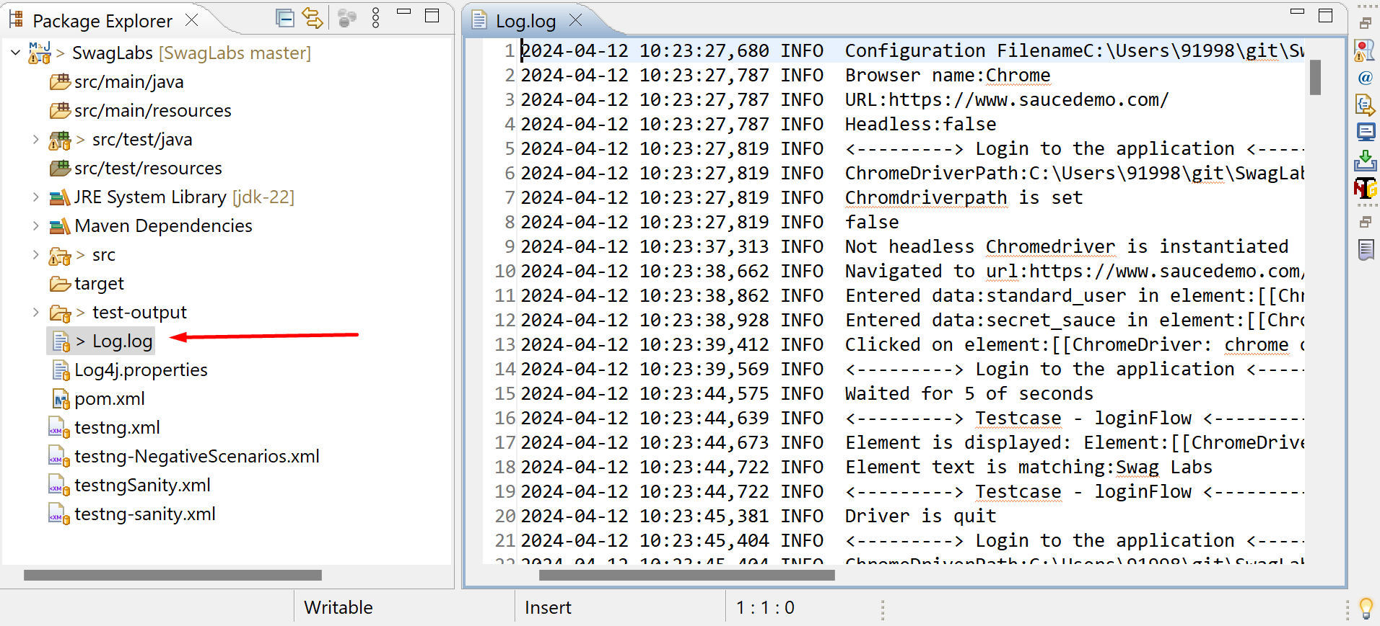

1. For failures screenshots will be taken at failed step and place in Screenshots folder

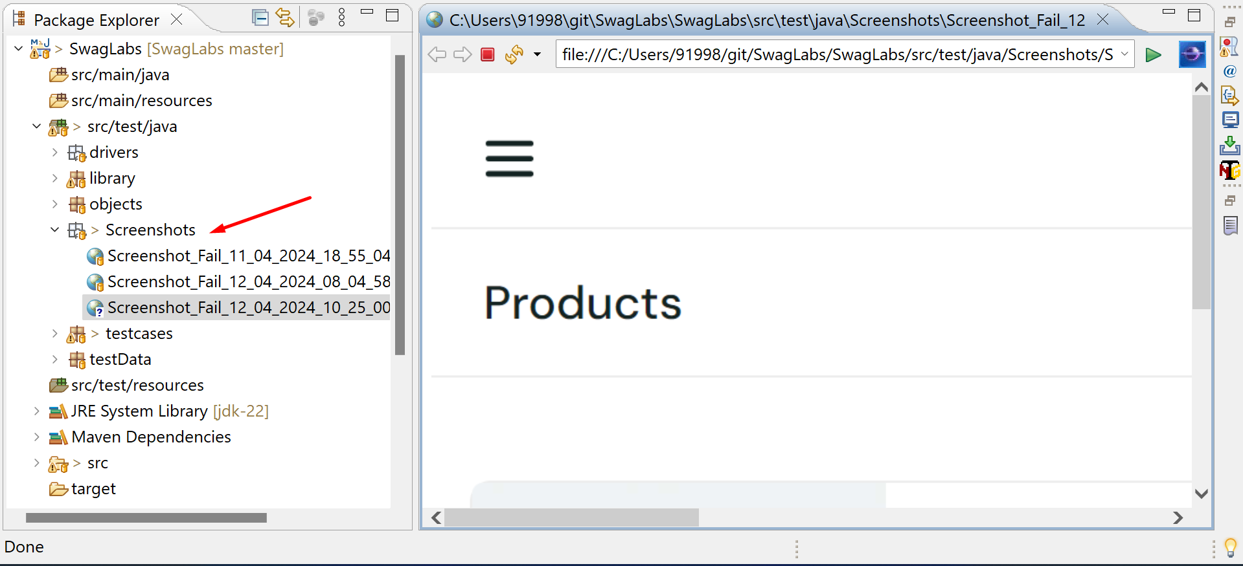

1. All testcases mentioned in task mail are named and arranged sequentially
2. Test purposelyFailLoginFlow is made to fail purposely to show screenshot capture in extent reports

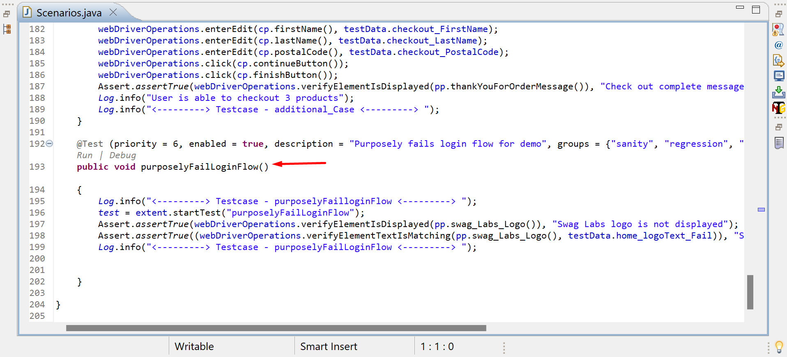

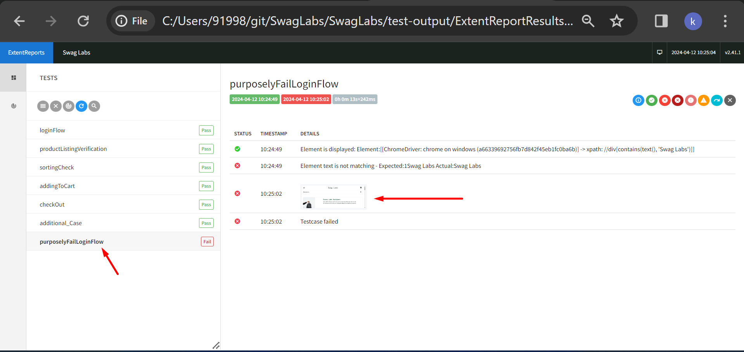

1. Each testcase is independent and can be run separately.
2. To disable any testcase, it can be marked **enabled = false**

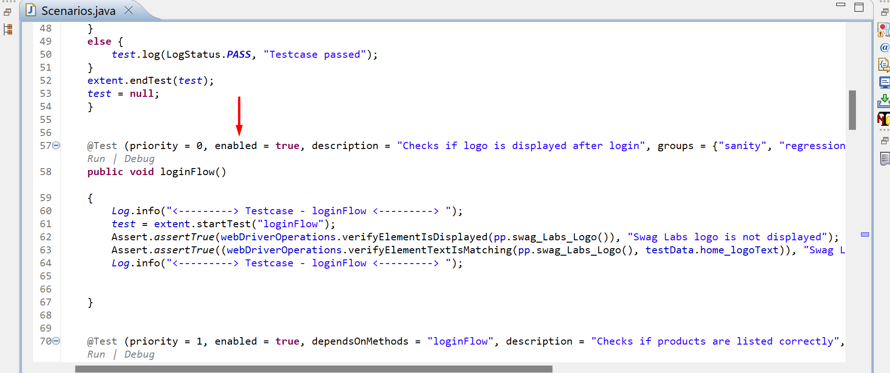

1. To run testcases based on groups testing-groups.xml can be used

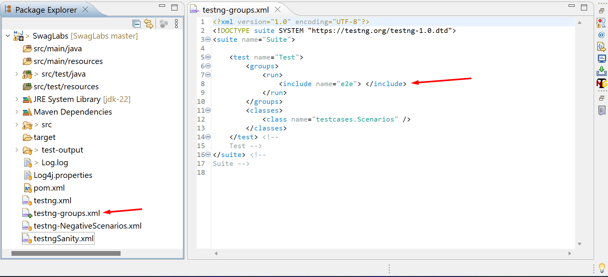

1. Dataprovider class can be used for data driven testing

